**Sally Mukami**

[Sally.mukami@womentechsters.org](mailto:Sally.mukami@womentechsters.org)

**PRACTICAL ACTIVITY 3: ON LINUX SYSTEM ADMINSTRATION**

1. List the processes for the current shell.

Use of the command ps .

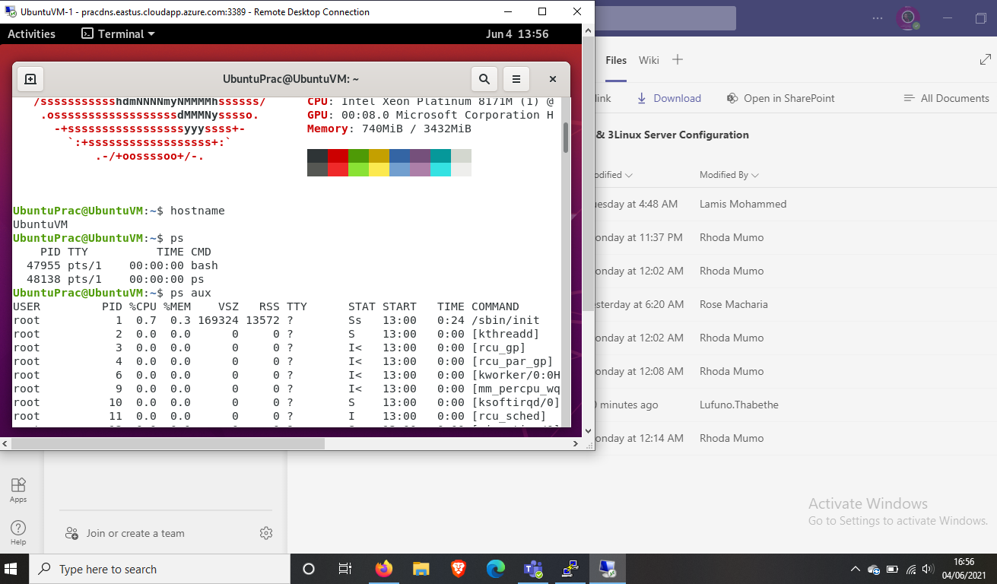

1. Display information about processes.

Use command ps –aux

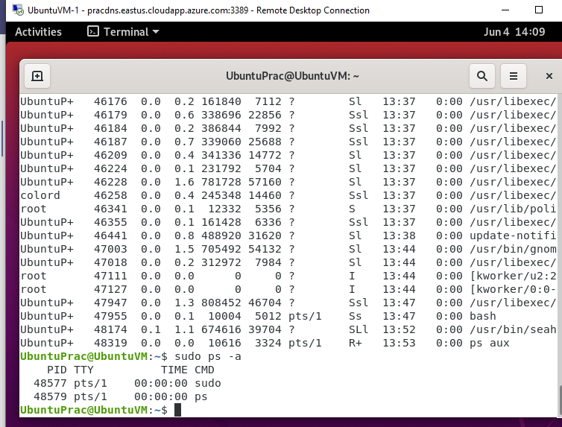

1. Display the global priority of a process and find out the column that provides.

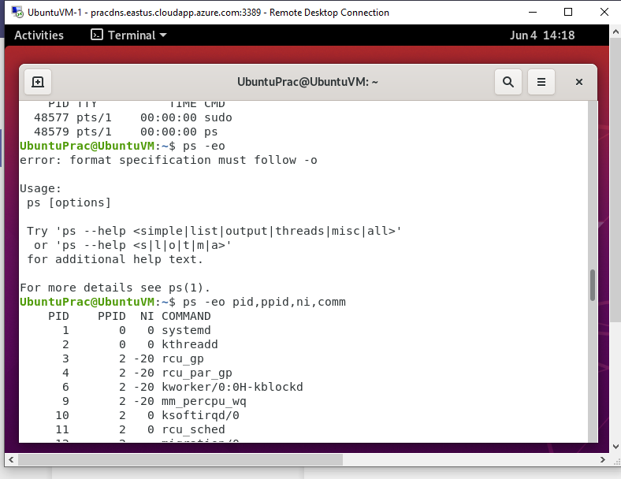

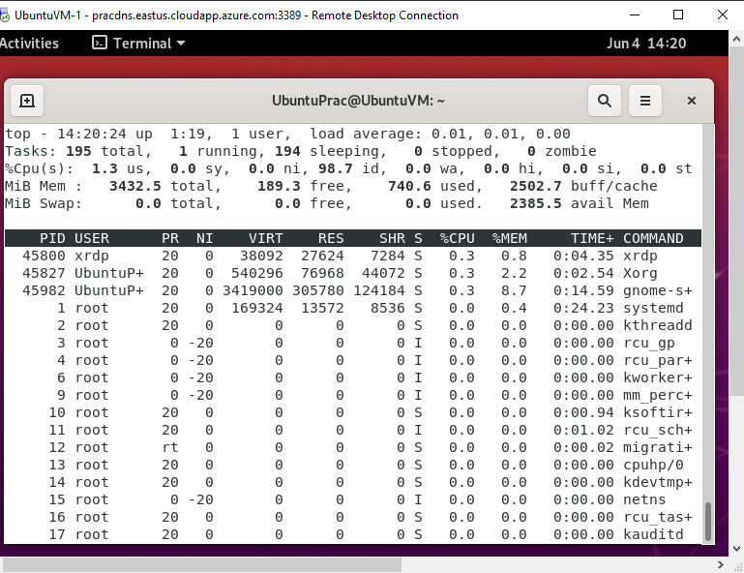

1. Change the priority of a process with default arguments.

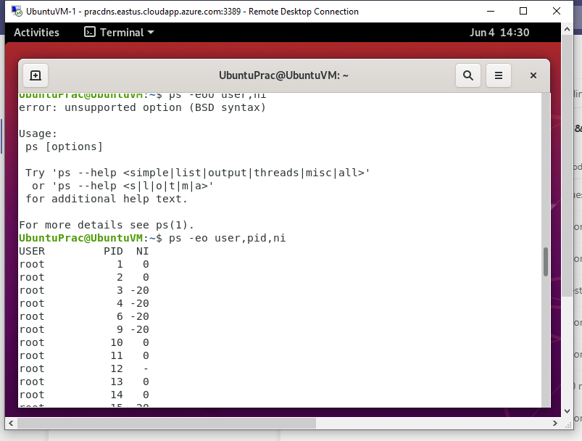

I narrowed down to the priority and nice columns then I used the renice command to change priority of process 47947 from 0 to 5

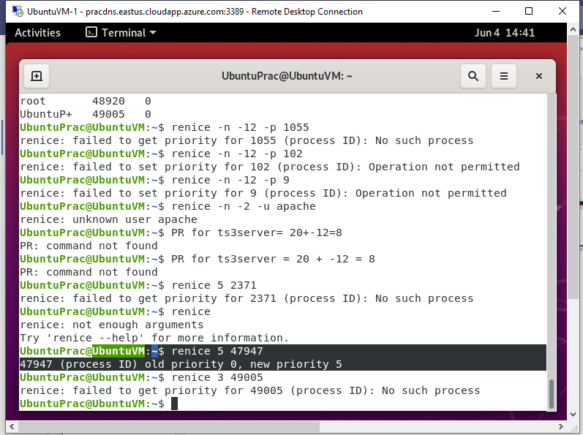

1. Display Virtual Memory Statistics.

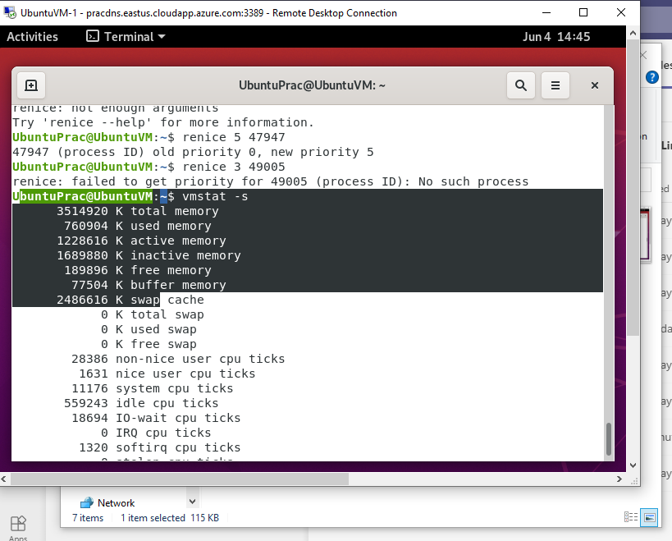

1. Display System Event Information.

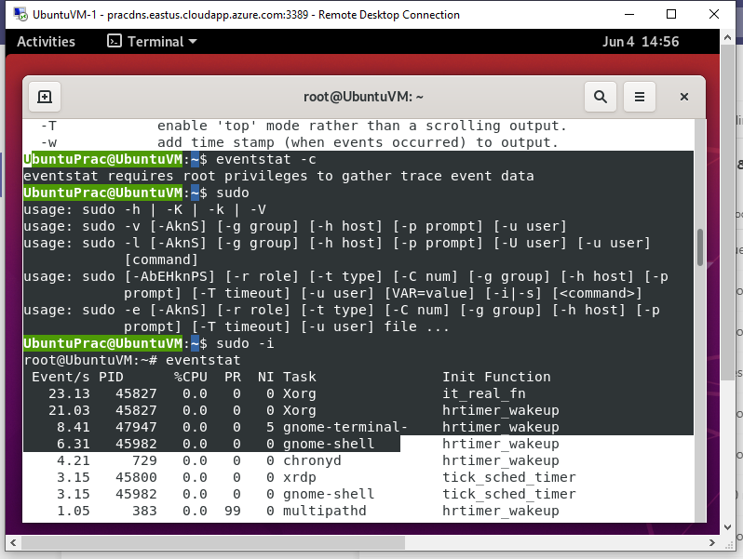

1. Display Swapping Statistics.

On using the swapon command the output was empty for there was no data, so I used the free command so I can get a clear view.

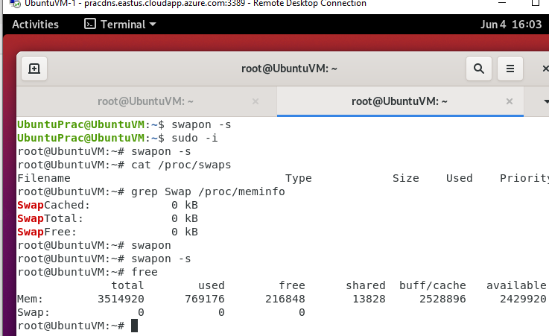

1. Check File Access statistics.

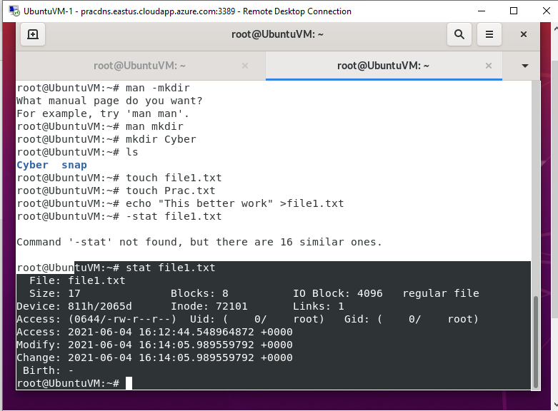

1. Check Buffer Activity statistics.
2. Check Disk Activity statistics.
3. Check Inter process Communication statistics.

In my understanding ‘top’ and ‘ps –aux’ provides detailed information about the process including disk activity, buffer and communication statistics

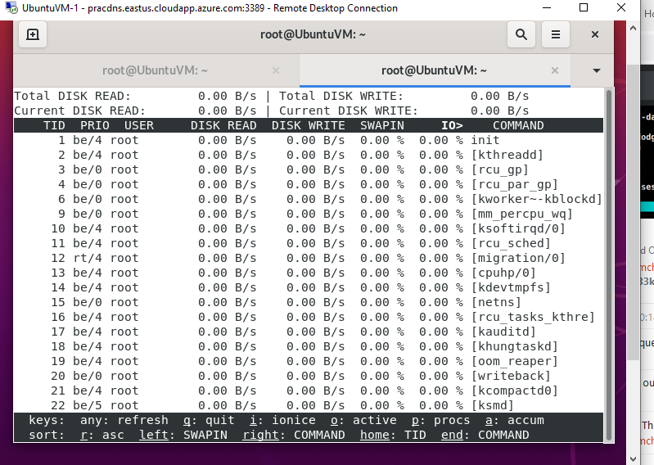

1. Check Unused Memory in the server.

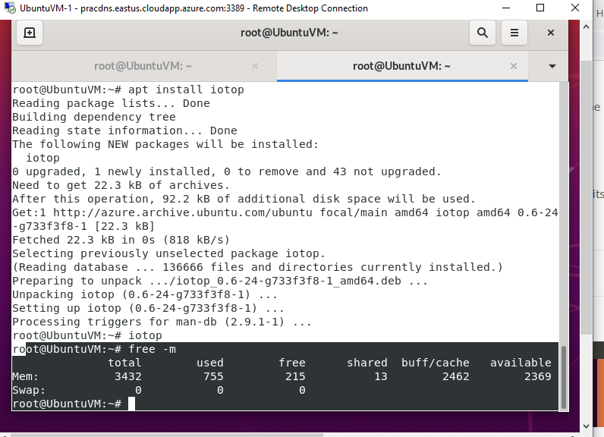

**Part 2 : Practical Activity Week 3**

Login to your terminal in Ubuntu.

1. Create a user account called user1 and another user2
2. Ensure user1 and user2 are password protected

Created the required users, assigned them groups username and password.

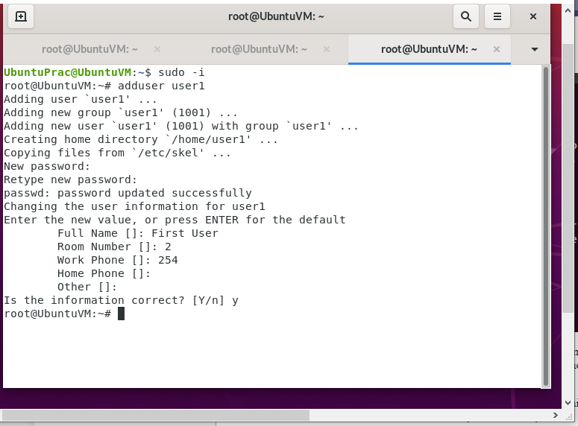

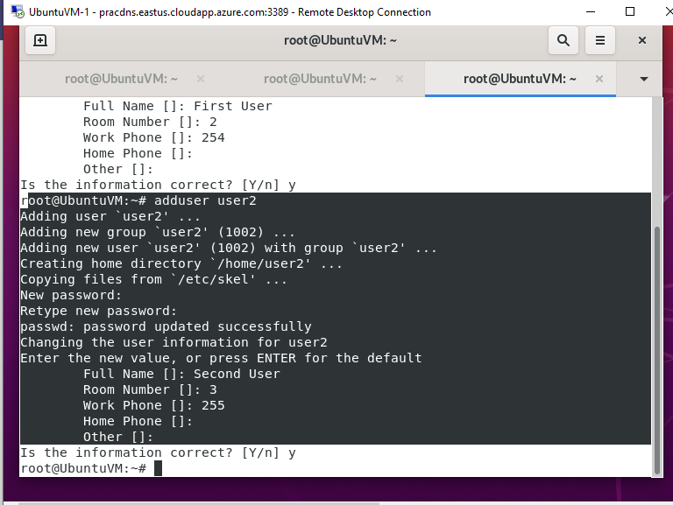

1. Logout and login as user1

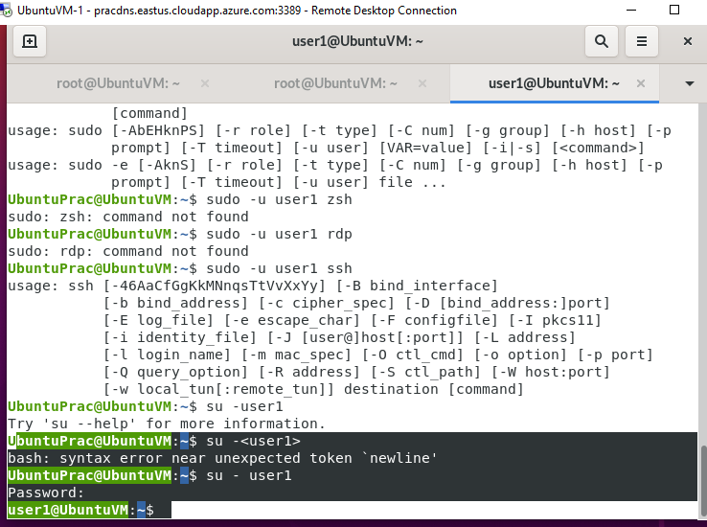

1. Create a testdir

To avoid confusion, I created a directory but named it Prac2

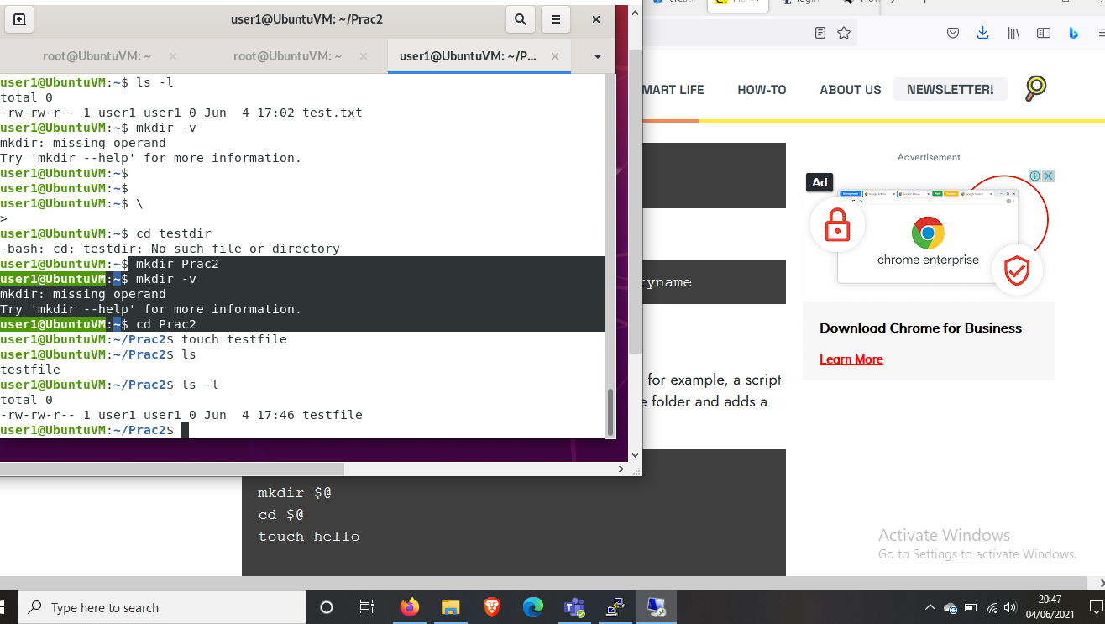

1. Create a file testfile in testdir

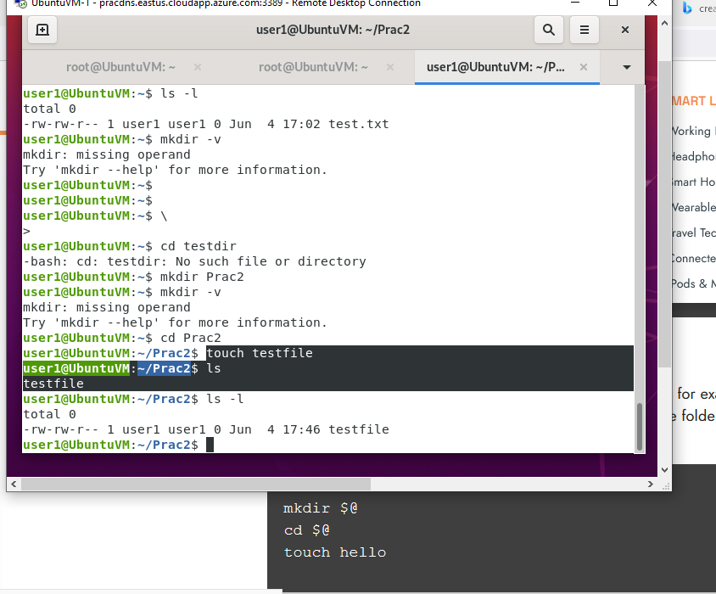

1. Verify the ownership and the group of the testfile

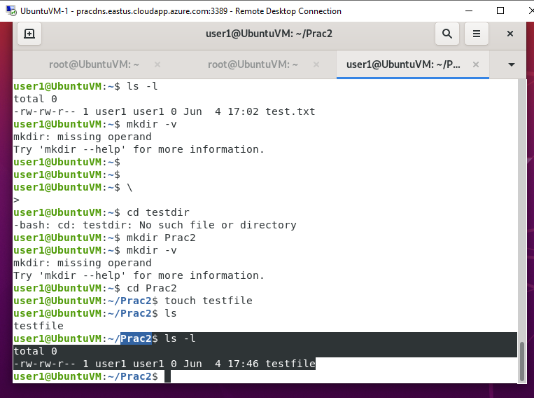

1. Switch to Superuser account

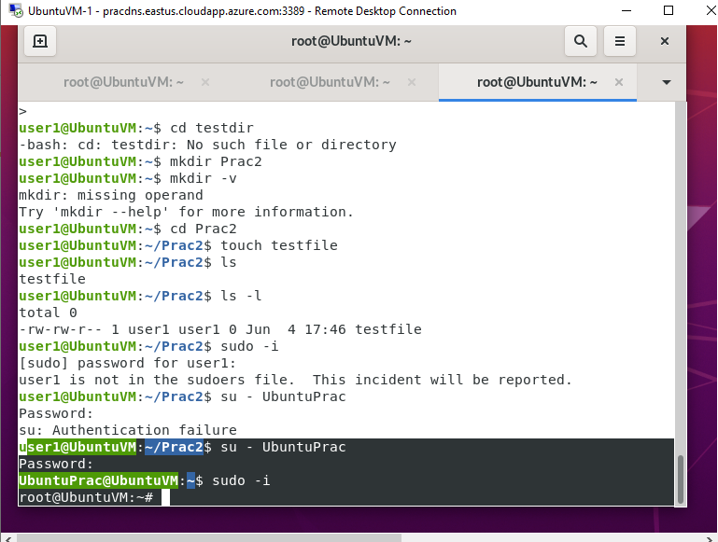

1. Create a public directory dir1

I created the directory “dir1” in “home” of the root user. Since it’s a public file that will be shared a created a group called ‘Project’ and added user1 and user2 to the groups. I later permitted user1 and user2 to write and read the contents of the file and created a subdirectory for each user eg, ‘user1_reports’

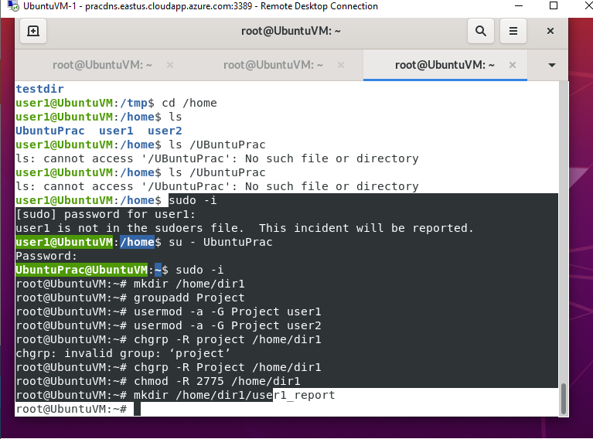

1. Logout and login as a normal user user1
2. Create a file userfile1 in dir1

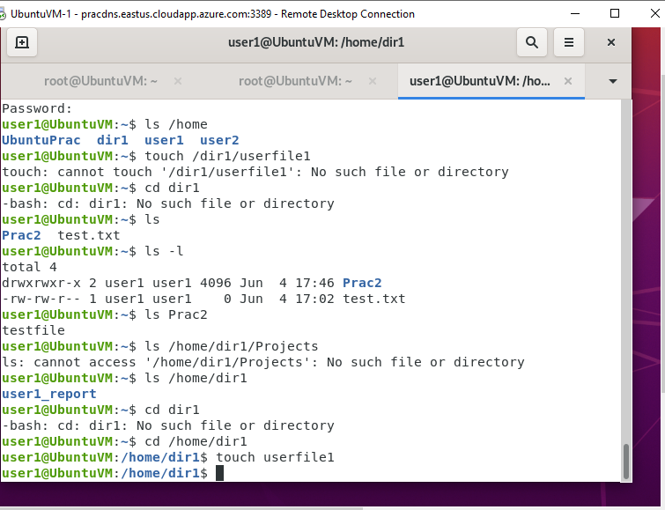

1. Login as a different user user2
2. Try to edit or remove the file

I switched to the user2 account and entered the dir1 directory. I was able to access its contents and even delete the user1file.

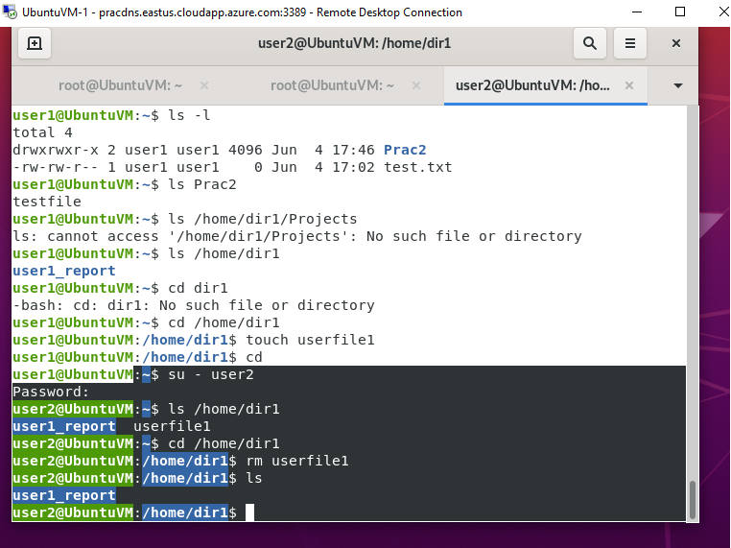

1. Temporarily disable user logins

I used the ‘sudo passwd –l’ to disable the user1 password, later I enabled it through the ‘sudo passwd –u' command

